INTRODUCTION:
A beam is a structural element that is capable of withstanding load primarily by resisting bending. The bending force induced into the material of the beam as a result of the external loads, own weight and external reactions to these loads is called a bending moment. Beams generally carry vertical gravitational forces but can also be used to carry horizontal loads (i.e., loads due to an earthquake or wind). The loads carried by a beam are transferred to columns, walls, or girders, which then transfer the force to adjacent structural compression members. In Light frame construction the joists rest on the beam.
Beams are characterized by their profile (the shape of their cross-section), their length, and their material. In contemporary construction, beams are typically made of steel, reinforced concrete, or wood. One of the most common types of steel beam is the I-beam or wide-flange beam (also known as a "universal beam" or, for stouter sections, a "universal column"). This is commonly used in steel-frame buildings and bridges. Other common beam profiles are the C-channel, the hollow structural section beam, the pipe, and the angle.
OBJECTIVE:
To Study the beam under different loads acting on it.
THEORY:
In General when the beam is subject to the loading on it deflects and some of the moments and reactions occur in that beam. By determining the loads and member at particular distance the bending moment and shear force can be known.
Shear Force: Shear force is an internal force in any material which is usually caused by any external force acting tangent (perpendicular) to the material, or a force which has a component acting tangent to the material.
Bending Moment: Bending moment is the algebraic sum of moments to the left or right of the section. In each case, by considering, either for forces or moments the resultants caused by applied forces to one side of the section is balanced by bending moment and shear force acting on the section.
A beam with a moment of inertia I and with Young's modulus E will have a bending stress f at a distance from the Neutral Axis (NA) y and the NA will bend to a radius R ...in accordance with the following formula.
M / I =  / y = E / R
Simply Supported Beam. Concentrated Load
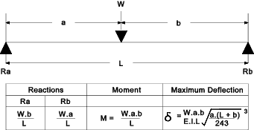

Simply Supported Beam. Uniformly Distributed Load
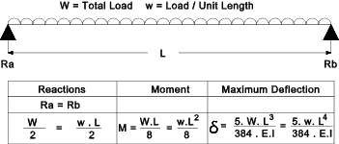

Cantilever. Concentrated Load:
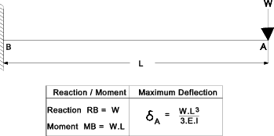

Cantilever Uniformly Distributed Load:
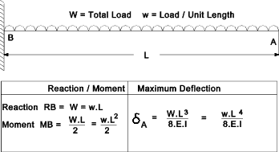
Fixed Beam Concentrated Load:
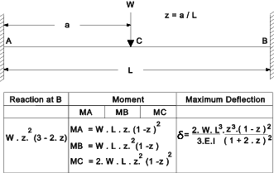
Fixed Beam. Uniformly Distributed Load:
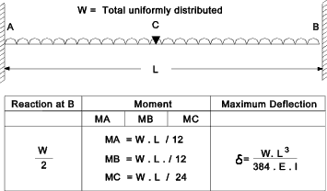

SNAP SHOTS:
The snap shots that are hand written those are
- Simply Supported
- Fixed beams
- Cantilever
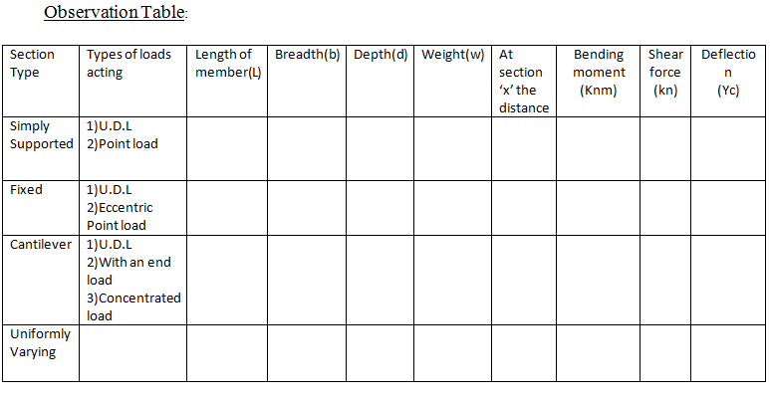
Output:
- Bending moment ________ (Knm)
- Shear Force _________ (KN)
- Deflections _________ (Yc)

QUIZ:
- What is a beam?
- What is point of inflection?
- What is Young’s modulus?
- What is the maximum deflection of a S.S. beam when point load is applied at the center?
- Bending moment profile for a S.S. beam under U.D.L is parabolic. (T/F)
- The ratio of change in length to the original length is ___________.
- Tension occurs at bottom of the cantilever beam when point load is applied at the center. (T/F)

REFERENCES:
- Theory of structures Volume: 1 by S.P.Gupta and G.S.Pandit
- Reference from √X MATHalino.Com
- Mechanics of Materials by B.C.Punmia
PART – 2
ANIMATION STEPS

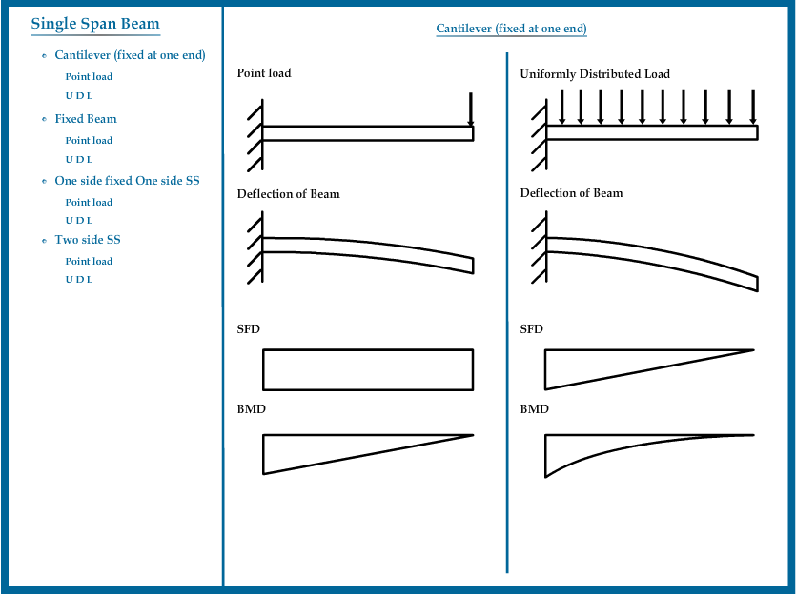

PART – 3
VIRTUAL LAB FRAME
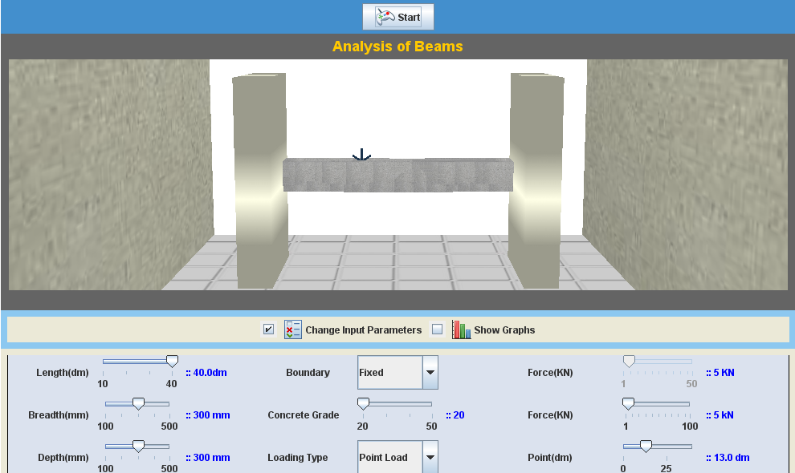

LABORATORY ROOM CONSISTS:
- Columns
- Beams
- Loads

INPUT:
- Dimensions of Beam (Length, Breadth, Depth)
- Boundary (Fixed, Simply Supported, Cantilever)
- Concrete Grade (M20, M25, …., M50)
- Loading type (Point Load, UDL)
- Location of Load

OUTPUT:
- Deflection
- SFD
- BMD

